It is required that you use Newyork Times (**top_stories)** api:

http://developer.nytimes.com/#h2-requests

to fetch data and display it as items in a list in addition to caching this data so it would be available offline.

The data in a top story section like (home,world,national,....etc) should be fetched from the apis only once and then displayed from cache next application launches or when changing sections without calling the apis again or depending on the internet connection.

(There should be no duplicate data)

The user should be able to change top story sections data through a “drop down menu” on top of the “list” with respect of course to the sections available in the documentation:

(home,world,national,....etc).

The parameters we would be concerned to see in a list item according to api response is:

-title

-published_date

-url (image)

Please check the image examples below to make things clear.

It is required that you write a clean maintainable code with no bugs and by whatever 3rd party libraries you wish to use.

Note that UI designs is left free for you and is not our big concern for this task as long as it is implemented properly and it meets this app’s core functionalities.

The deal line for this task would be 12am 22/6/2017.

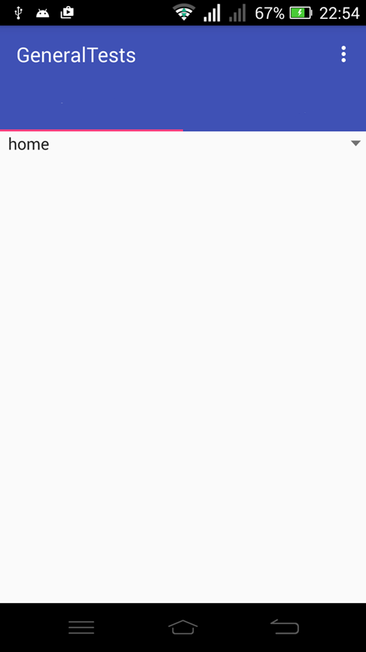

image

title

Publish date

title

Publish date

